Howard University
College of Engineering and Architecture
Department of Electrical Engineering & Computer Science

Large Scale Programming
Fall 2024

Midterm Exam – Part I
October 17, 2024

Part I: 50 pts. (essay questions)

Instructions:
- Submit completed exam to your github repository under package org.howard.edu.lsp.midterm

Verify that the commit(s) completed successfully

- OPEN BOOK, OPEN NOTES. THERE IS NO COLLABORATION ON THIS EXAM
- Site any and ALL references for anything obtained off the internet.

Question 1. (10 pts.)

You are reviewing the following class in a Fitness Tracking System. The class is intended to manage various aspects of a user’s fitness activities.

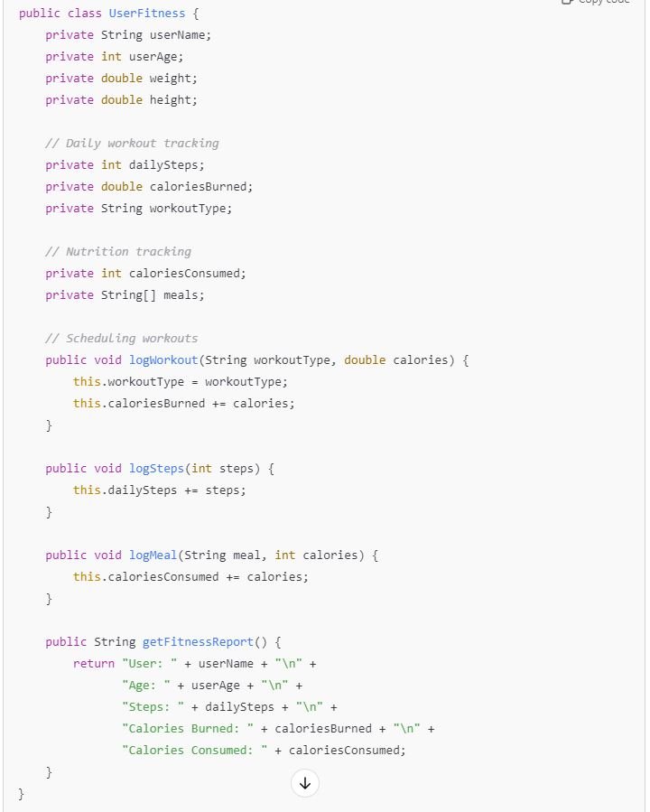

Tasks:
- Analyze the UserFitness class. Explain why this class has low cohesion. (5 pts.)

The UserFitness class has low cohesion because it mixes several distinct responsibilities:
- User information management: It stores data about the user (e.g., userName, userAge, weight, height).
- Workout tracking: It handles workout-related details (workoutType, caloriesBurned, dailySteps).
- Meal tracking: It manages nutrition tracking (caloriesConsumed, meals).
- Fitness report generation: It generates reports using the getFitnessReport() method.
Each of these concerns could be separate, making the class responsible for too many different things. This violates the Single Responsibility Principle (SRP) and makes the class harder to maintain and extend.

- Describe, in general, how you would split the UserFitness class into more cohesive classes. Your answer should not be a complete design. (5 pts.)

To improve cohesion, we can split the class into more focused classes based on the different responsibilities. Here's a general idea of how it can be done:
- UserProfile Class: Handles user-specific information, such as userName, userAge, weight, and height.
  - This class is responsible for storing user-related data and possibly methods to update or access the user's profile details.
- WorkoutTracker Class: Manages workout-related activities, such as workoutType, caloriesBurned, and dailySteps.
  - This class will focus on logging workouts and steps, calculating calories burned, and providing workout-related reports.
- NutritionTracker Class: Manages meal tracking, such as meals and caloriesConsumed.
  - This class will be responsible for logging meals, tracking calories consumed, and offering nutrition-related information.
- FitnessReport Class: Generates fitness reports by aggregating data from other classes (e.g., UserProfile, WorkoutTracker, and NutritionTracker).
  - This class would focus on combining the relevant data into a report format.

Question 2. (5 pts.)
Given the following, answer the below questions.

A university manages its students using a program that has a class Student with subclasses FirstYear, SecondYear, and ThirdYear for year-specific state and behaviors. The program has a List that contains all Students.

- Should Student be a class, an abstract class or an interface? Explain your answer

Student should be an abstract class.
- Why an Abstract Class: The Student class provides a general framework for all students (FirstYear, SecondYear, and ThirdYear), including shared fields and behaviors (like student ID, name, and common methods like attendClass()). However, the specifics (e.g., year-specific behaviors or attributes) differ depending on the year. This makes it an ideal candidate for an abstract class. Abstract classes allow some shared implementation, while forcing subclasses to define their own specialized behavior. It also ensures that the common structure and behaviors for all students are enforced.
- Why Not an Interface? Interfaces do not allow shared implementation, just method signatures.
- Why Not a Regular Class? A regular class would allow instantiation, but we likely don't want to create instances of Student directly An abstract class prevents the instantiation of Student itself, which fits our scenario better.

- At the end of each year, the third-year students graduate and must be removed. This is done by passing the list to the following method:
void removeThirdYears(List<Students> students) {
for (Student student : students) {
try {
ThirdYear = (ThirdYear) student;
students.remove(thirdyear);
}
}
}
Why is the above method flawed? Hint: Another Arthur Riel heuristic (5 pts.)

The method is flawed for the following reasons:
- Concurrent Modification Issue: The method is trying to remove items from the list while iterating over it. This leads to a Concurrent Modification Exception because modifying a list during iteration using a traditional for-each loop is not allowed. When you remove an item from a list during iteration, the iterator’s structure gets invalidated, which is problematic.
  - Solution: Instead of using a for-each loop, you should use an Iterator to safely remove elements during iteration. The Iterator class has a remove() method designed specifically for this purpose. Here’s an example of how to do this:
- Class Cast Exception: The method is trying to cast every Student object to ThirdYear. This will throw a ClassCastException if the student is not a ThirdYear. Not all students are instances of ThirdYear, so casting all of them is unsafe. You should first check if the student is an instance of ThirdYear using instanceof.
By fixing these issues, the method will work as intended without throwing exceptions.

Question 3. (5 pts.)
Given the following, answer the below questions.

public class BankAccount {
public String accountHolderName;
public String accountNumber;
public double balance;
public double interestRate;

public BankAccount(
String accountHolderName,
String accountNumber,
double initialDeposit,
double interestRate) {
this.accountHolderName = accountHolderName;
this.accountNumber = accountNumber;
this.balance = initialDeposit;
this.interestRate = interestRate;
}

// Exposed implementation for adding interest
public void addInterest() {
double interest = balance * (interestRate / 100);
balance += interest;
}

// Exposed implementation for deposits
public void deposit(double amount) {
balance += amount;
}

// Exposed implementation for withdrawals
public void withdraw(double amount) {
balance -= amount;
}
}

- Is BankAccount well-encapsulated? Why or why not? If so, describe what changes you would make to the class. Otherwise, state nothing. (5 pts.)

No, the BankAccount class is not well-encapsulated. In the current BankAccount class, the following issues violate encapsulation:
- Public Instance Variables: The variables accountHolderName, accountNumber, balance, and interestRate are all declared as public. This allows external code to directly access and modify these variables, potentially putting the object into an invalid or inconsistent state. For example:
  - Someone could directly change the balance to an arbitrary value.
  - The accountNumber and accountHolderName could be modified directly, which may not be allowed for a real bank account.
To improve the encapsulation:
- Make instance variables private: To encapsulate the class properly, we should make all instance variables private. This ensures that external code cannot directly modify these variables.
- Provide controlled access through getter and setter methods: To access or modify the variables, we should provide getter and setter methods as needed. However, for sensitive data like accountNumber, you might not want to provide a setter to prevent changes.
- Restrict balance manipulation: The balance should only be changed through specific methods like deposit(), withdraw(), and addInterest(). External code should never be allowed to modify the balance directly, as this could violate business rules (like overdraft protection, minimum balance requirements, etc.).

By making these fields private and providing controlled access through getters and setters, we can improve its encapsulation and protect the integrity of the object's state.

Question 4. (10 pts.)
Given the following, answer the below questions.

Given:
A car manufacturer uses Java software to track current vehicles being built. The UML diagram below shows an excerpt of the current software structure. You should assume the presence of other appropriate fields and methods

Car
getTrimLevel()
Engine
accelerate()
getFuelLevel()
Base
Sports
Luxury
Electric
Petrol

Each car can be built to one of three trim levels: Base, Luxury or Sport. They can also be configured with an electric or petrol engine. At various points in the manufacturing process the customer can choose to change the trim level.

Task:
- Explain in detail why the current structure does not support this. (5 pts.)

The issue lies in how the current structure is designed:
- Inheritance-based trim levels: The Car class has three subclasses: Base, Sports, and Luxury. Each of these represents a specific trim level.
In this design, the trim level is tightly coupled with the specific subclass of the car. For example, if a car is initially created as a Base trim, it will be an instance of the Base class. If the customer wants to change the trim to Luxury, there is no way to dynamically change the car’s trim level because the trim is tied to the object's class type (Base, Sports, or Luxury). You cannot simply change an object’s class at runtime in Java.
- Rigid Inheritance Hierarchy: The rigid inheritance structure means that to change a car's trim level, you would have to destroy the current object and create a new one of the desired subclass (e.g., change from Base to Luxury). This is inefficient and does not align with the real-world scenario where a car's trim level should be modifiable during the manufacturing process.

- Describe how to refactor the structure to allow trim-level change for a car to dynamically change. Hint: How would you modify Car to use composition to solve the problem? (5 pts.)

To allow dynamic changes to a car's trim level, we should refactor the design to use composition instead of inheritance. Here's how to approach it:
- Introduce a TrimLevel class or interface: Instead of using subclasses for different trim levels, we can create a TrimLevel interface or class with specific implementations for each trim (e.g., BaseTrim, SportsTrim, and LuxuryTrim).
- Use composition in the Car class: The Car class should now contain a TrimLevel object rather than inheriting from specific trim classes. This allows the car to dynamically change its trim level by simply changing the TrimLevel object it holds.
- Dynamically change the trim level: Now, when the customer wants to change the trim level of a car, the setTrimLevel() method can be used to update the TrimLevel object without needing to create a new car object or switch between subclasses.
By switching to composition, we ensure that a car’s trim level can be changed dynamically without being bound to inheritance limitations.

Question 5. (5 pts.)
Suppose you are about to code a particular class and find that you have written another class with nearly the functionality that you now are developing. This means that the two classes in large parts contain the same code, but in smaller parts have different code. Explain in detail why this may be a problem and how to solve it. Give your answer in terms of Arthur Riel’s design heuristics.

This situation violates Arthur Riel’s heuristic of "Avoid duplicate code", which advises against having multiple classes that perform nearly identical functions with minor differences. Code duplication leads to maintenance issues, as any change or bug fix must be applied to both classes, increasing the risk of inconsistency. To solve this, you can refactor the shared code into a common superclass or use composition where the common functionality is encapsulated in a separate class, allowing both classes to reuse the shared functionality. This enhances code reusability and ensures future changes only need to be made in one place.

Question 6. (5 pts.)
Suppose we need to store instances of the classes Car and BankAccount in a database. To obtain low coupling it may seem as if the functionality to save an instance should be in precisely those classes, since they have the information that shall be saved. Why is it unwise to place the database calls there?

Placing database calls directly in the Car and BankAccount classes would violate the Single Responsibility Principle (SRP) and increase coupling. These classes should focus solely on representing their domain-specific behavior, such as car-related or bank-related operations. If they also handle database operations, they become responsible for both business logic and persistence logic, leading to tightly coupled code that is harder to maintain, test, and modify. A better approach is to separate concerns by using a data access layer (like a repository or DAO pattern), where the persistence logic is handled independently, promoting low coupling and easier code maintenance.

Question 7. (5 pts.)
Given a set of requirements, what conditions must be met to make it appropriate to create a new class hierarchy using inheritance? Neither superclass nor subclass exist before, the question is about designing a new class hierarchy.

When designing a new class hierarchy using inheritance, certain conditions should be met: (1) there is a clear "is-a" relationship between the superclass and subclasses, meaning subclasses represent specialized versions of the superclass, (2) the superclass contains shared behavior and attributes that will be inherited by the subclasses to avoid code duplication, (3) the subclasses need to extend or customize some behavior of the superclass while still maintaining a logical relationship, and (4) the design should respect the Liskov Substitution Principle (LSP), meaning any instance of the subclass should be usable wherever an instance of the superclass is expected without breaking functionality.

Question 8. (2.5 pts.)
Describe the difference between inheritance and composition why would you choose one over the other.

Inheritance represents an "is-a" relationship where a subclass inherits properties and behavior from a superclass, allowing the subclass to extend or modify shared functionality. Composition, on the other hand, represents a "has-a" relationship, where one class contains an instance of another class to use its behavior, promoting flexibility and reuse without tight coupling. You would choose inheritance when there is a clear hierarchical relationship and shared behavior across classes. However, you would prefer composition when you want more flexibility, avoid tight coupling, or when the behavior of a class can be reused or changed dynamically without affecting class hierarchies.

Question 9. (2.5 pts.)
Explain the meaning of cohesion and describe whether low or high cohesion is better.

Cohesion refers to how closely related and focused the responsibilities and functions of a class or module are. High cohesion means that a class or module has a well-defined, single responsibility and contains methods and attributes that are strongly related to its core functionality. Low cohesion, on the other hand, occurs when a class or module handles unrelated or loosely related tasks, making it harder to maintain and understand. High cohesion is better because it leads to more modular, maintainable, and understandable code, where each class or module focuses on one aspect of the system, promoting the Single Responsibility Principle.

References:

  - ChatGPT 4o

